# ISEE Dashboard installation guide_V3 2024_11_25

This is a quick guide to be able to use ISEE dashboard on your computer. It has been tested among colleagues, who are familiar with Python coding and open source software, and no major issues were reported. Now, the intent of this document is to make ISEE dashboard accessible to a broader audience. Hence, feel free to communicate any problems or to formulate any recommendations that would clarify the content of the present document (antoine.maranda@ec.gc.ca).

** in the following pages, anything that is between {curly brackets} refers to a variable. For instance if you chose to put the ISEE dashboard data in this folder : F:\GLAM_DASHBOARD\ISEE_Dashboard. When it is written *create the following folder: {your local folder}\data* it means that you should create F:\GLAM_DASHBOARD\ISEE_Dashboard\data folder.

**FOR PREVIOUS USERS (using the dashboard before 2024-11-25):**

You can keep the same installation as before although you need to do 2 steps:

1. Update your Streamlit version :

In a command prompt activate your streamlit environment with : conda activate streamlit

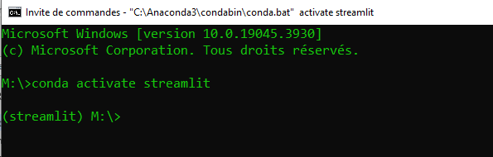

Then type: pip install streamlit==1.30 --force-reinstall

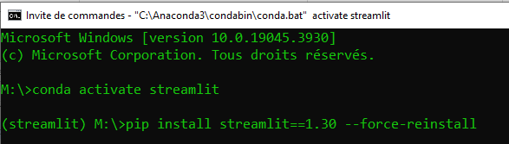

1. Follow step 4 of this guide and now run the dashboard according to step 5

## Installation main steps

The following steps will be described in more details throughout the document.

1. Download and unzip ISEE dashboard files
2. Download, Install and setup Anaconda on your computer
3. Create conda environment with dashboard requirements
4. Adjust paths in the code to point on your local repositories
5. Run the Dashboard

## Download and unzip ISEE dashboard files

All necessary files can be found on the GLAM sharepoint following this link: [ISEE_Dash_portable](https://ijccmi.sharepoint.com/:f:/s/GLAM/EhRoYbNdDexDoffL5hnx4d4BNTSg0ZDqjToIJOR1HezUwg?e=uVu31B)

Once downloaded, you can unzip each of the folders. Place the unzipped folders at a specific location that will be now referred as {your local folder}

## Download, Install and setup Anaconda on your computer

If you already have Anaconda on your machine you can skip to step 3.

If not, please follow these steps (probably the most complicated part of the process don’t be discouraged)

### 2.1: Download Anaconda

* + Go to the Anaconda website ([Download Now | Anaconda](https://www.anaconda.com/download/success)) and download the installer for Windows.
  + Choose the version for Windows.
  + Once downloaded, open the installer to begin the installation.

### 2.2: Install Anaconda

* + **Launch the installer** and follow the prompts:
    - Click **Next** on the welcome screen.
    - Agree to the license agreement.
    - Choose the installation type (All Users or Just Me). Selecting **Just Me** is usually fine for personal use.
    - **Select the installation location**. You can leave it as the default location or choose a custom one.
  + **Add Anaconda to your PATH environment variable**:
    - During installation, select the checkbox **"Add Anaconda to my PATH environment variable"**. This option will make it possible to run Conda commands directly from the Command Prompt.
    - If you don’t see this option, you may need to modify PATH manually after installation (covered in Step 2.3).
  + Click **Install** to complete the process.
  + When the installation finishes, click **Next**, and then **Finish**.

### 2.3: Verify Installation and Set PATH (if needed)

* + **Open Command Prompt**:
    - Press **Win + R**, type cmd, and hit **Enter**.
  + **Check Conda Installation**:
    - Write the following command to verify that Conda is installed and press enter:

conda --version

* + - If it returns a version number (e.g., conda 4.10.3), Conda is successfully installed and ready to use.
  + **If Conda Command Is Not Recognized**:
  + **Set PATH Manually**:
    - **Type “env” on the search bar on the bottom left of your screen**
    - 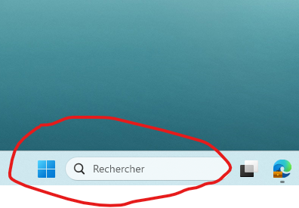
    - **Select** "Edit environment variables for your account" from the results.
    - Under **Users variables**, find the **Path** variable, select it, and click **Edit**.
    - Click **New** and add the following path:

{Where you installed Anaconda}\Anaconda3

* + - Also add:

{Where you installed Anaconda}\\Scripts

* + - Click **OK** to save and close all dialog boxes.
  + Close and reopen Command Prompt, then verify Conda with conda --version again.

## 3. Create conda environment with dashboard requirements

* + **Open Command Prompt**:
    - Press **Win + R**, type cmd, and hit **Enter**.
  + Write: conda env create -f "{your local folder}\ISEE_Dashboard\streamlit.yml" and press enter
  + Once the environment is installed, activate it by writing: conda activate streamlit and press enter

Your command prompt window should look like this :

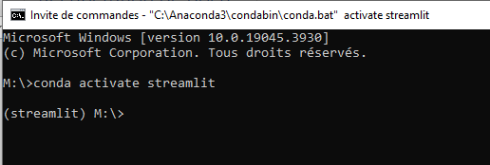

## Adjust paths in the .bat file

* + Edit the following file with any IDE (or Notepad if you don’t have any) by drag and dropping the file in a IDE or by right clicking and selecting “edit with Notepad++” (DO NOT SIMPLY DOUBLE CLICK ON IT YET) :

"{your local folder}\ISEE_Dashboard\launch_dash.bat"

Once opened, edit the following line:

Line 1:

IF NOT DEFINED ISEE_DASH_ROOT (SET ISEE_DASH_ROOT={your local folder} \ISEE_Dashboard\DASHBOARDS\ISEE)

Line 3:

IF NOT DEFINED CONDA_PATH (SET CONDA_PATH="{Path on your computer where the conda.bat file has been installed}")

Line 4:

IF NOT DEFINED ISEE_DASH_DATA (SET ISEE_DASH_DATA={your local folder })

It should look like this :

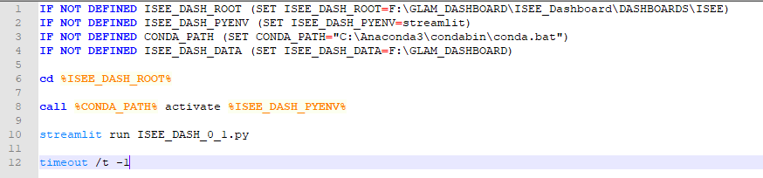

* + Save your edits and close the file

## Run the Dashboard

Now you can simply double-click on "{your local folder}\ISEE_Dashboard\launch_dash.bat"

A command prompt should open and automatically launch the Dashboard in a web browser:

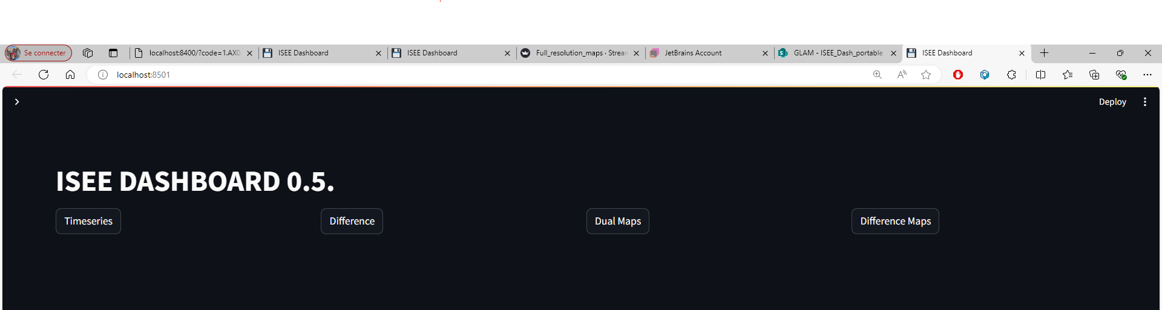

You then click on one of the four tabs to display different type of plots, which you can adjust with the widgets on the left:

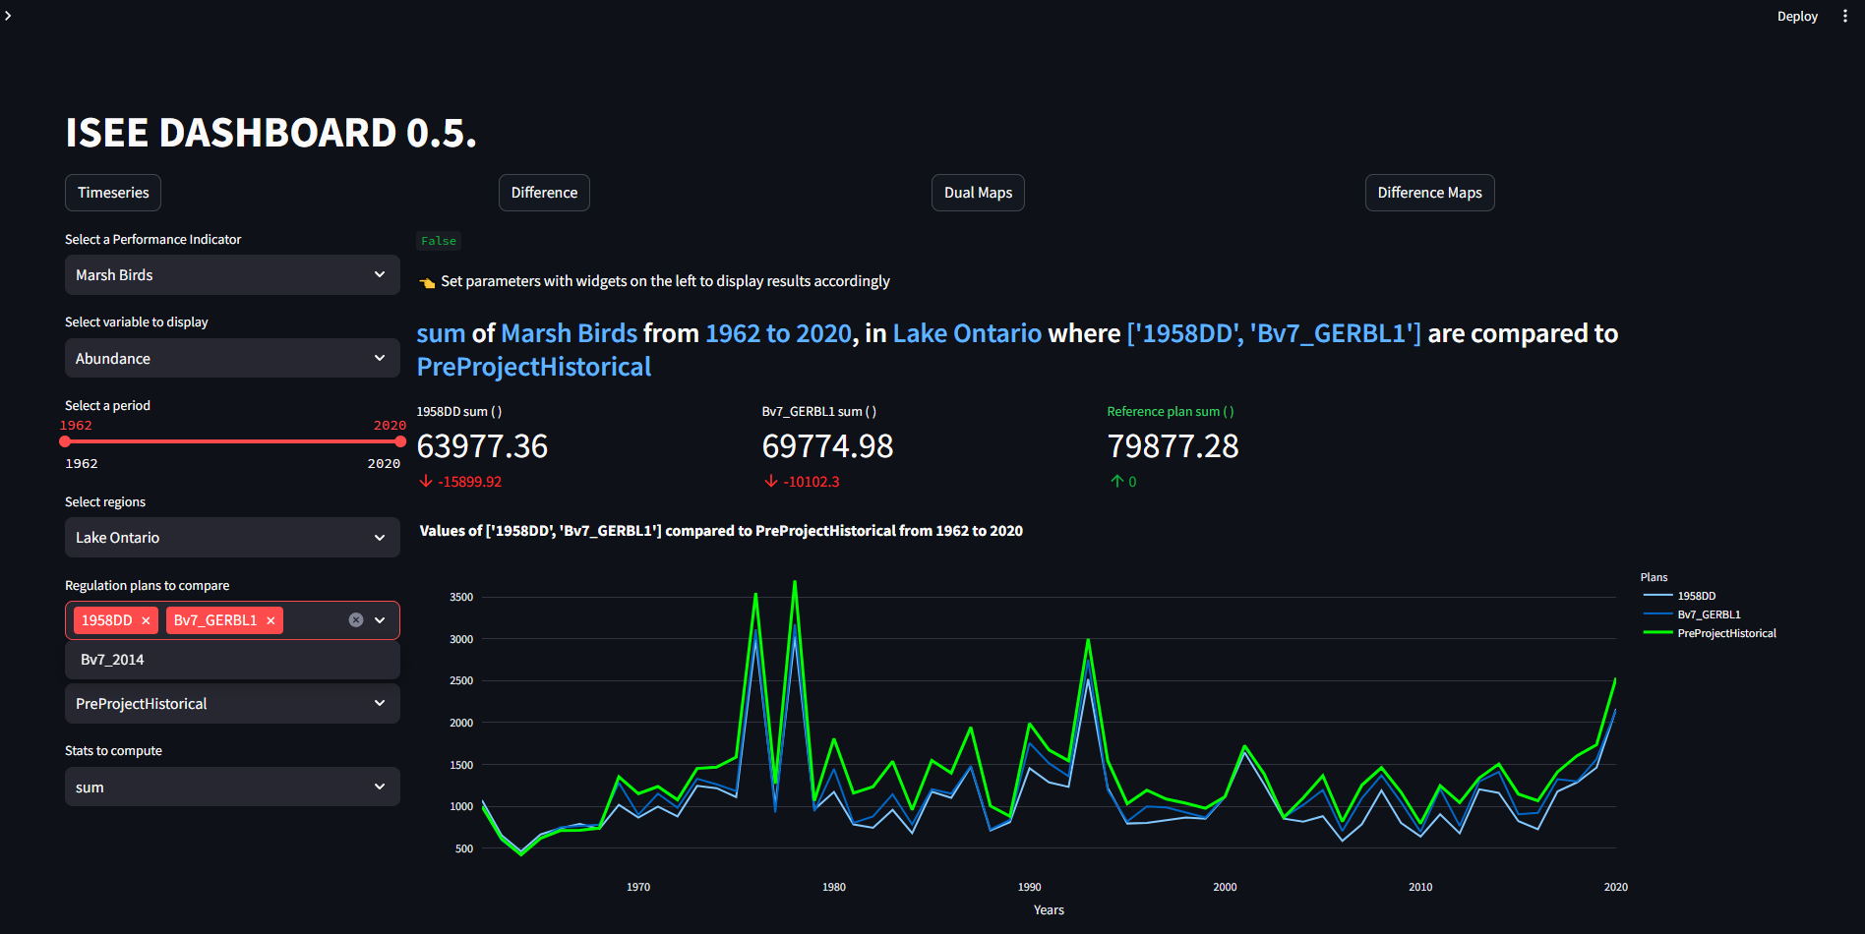

**If you need to stop the dashboard and rerun:**

Close the command prompt that was automatically opened.

Double click on "{your local folder}\ISEE_Dashboard\launch_dash.bat" file